Gasser Ahmed

[gasser18@vt.edu](mailto:gasser18@vt.edu)

ECE 5484, Project 2

Section 1 – Objectives:

Design and write an assembly language program for the MARIE processor that inputs, transforms,

stores, and then outputs a sequence of characters from the set A-Z.

By following the steps below:

1. Understand, design, and write the Rotate-13 subroutine then test with constants i.e. ‘A’.
2. Design/write and test the input phase.
3. Design/write and test the output phase.
4. Initialize/define symbols, constants, and data that will be used in both input and output phases.
5. Design/write code that combines all the steps above (Rotate-13 subroutine, input, output, and initialization phases) including the processing phase that takes every input, processes Rotate-13 subroutine on it, then stores the result at the current pointer memory location so it can be used later in the output phase.
6. Debug and test the full code by following Test 1 (inputting “VIRGINIA”) and Test 2 (inputting “GRPU”) scenarios and make sure the output is correct i.e. “IVETVAVN” and “TECH” respectively after running both scenarios without reassembling or reloading. Also, make sure the memory locations contain the right values.

Hint: To make the output cleaner, I added a space character to be displayed after every run to separate between the output of multiple runs. Also, after each character output, I clear value stored for that character in the memory location to avoid outputting previous run values in the next new runs.

Section 2 – Design Description:

The program inputs a sequence of characters from the set A-Z (capital letters only), stores each character in memory after it is transformed by the trivial ROT13 cipher, and then, after character input completes, it outputs the transformed characters.

To achieve that, we start the program at location 100 hexadecimal and initialize character pointer (Ptr) to start of block (200 hexadecimal). We also initialize InVal and Hold variables with 0 and other constants like ChA, ChZ, ChPe, Val13, etc. so they can be used in later phases. After we finish initialization, we start the input phase by taking an input value from the user and store it into InVal to be used in the transformation process. Then, we subtract ChPe from that value, if the result is 0, that means the input was period ‘.’ so we need to end that phase and reset the Ptr location to point to the start of the string to be ready for the output phase, otherwise, we will proceed with the transformation operation by calling “Process” which will start “ROT13” subroutine and start the transformation, store the result in memory (location stored in Ptr), increment Ptr location for the next input character and repeat the loop until user inputs ‘.’ to end that phase and move to the output phase.

Once we move to the output phase, we load the character found at address Ptr and check if the character is null, that means we reached the end of the string so we exit/halt the program, otherwise, we output that character, clear it from the memory (to avoid printing old previous run values in the next new runs) then we increment Ptr to move to the next character and we repeat the output loop until the end of the string (null character found).

Once the output phase is done, we add a space character to the output to separate current output from next run's output then we quit/halt the program.

Section 3 – Testing and Results:

After running Test 1 with input “VIRGINIA”, I was able to get the right “IVETVAVN” output, then after making another run without reassembling or reloading and with input “GRPU”, I got “TECH” as the output for that run.

Test 1 Output & Memory Screenshots:

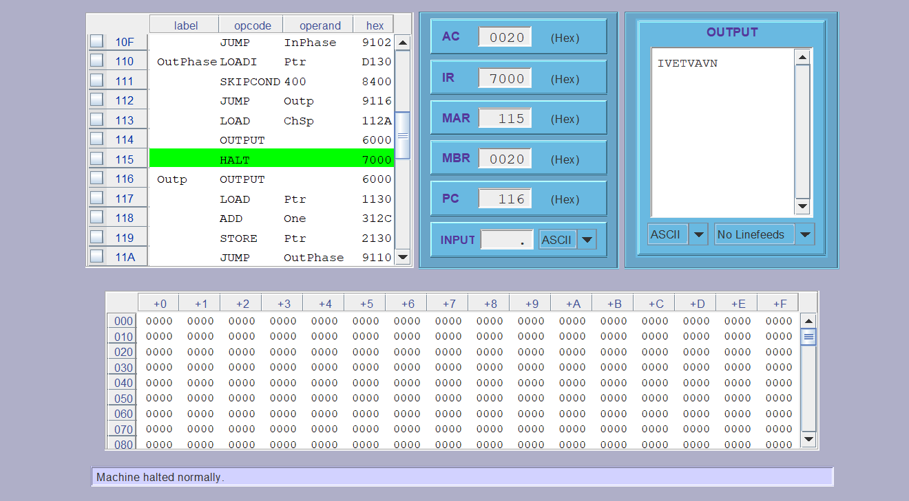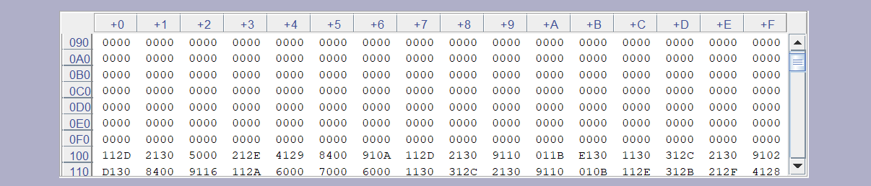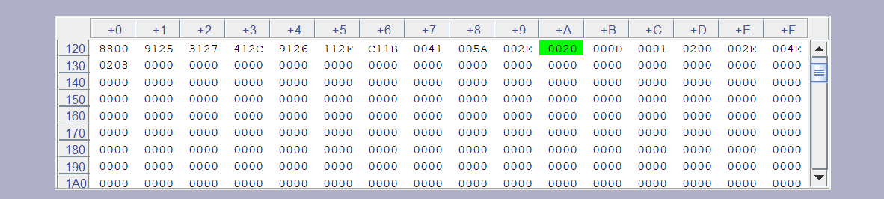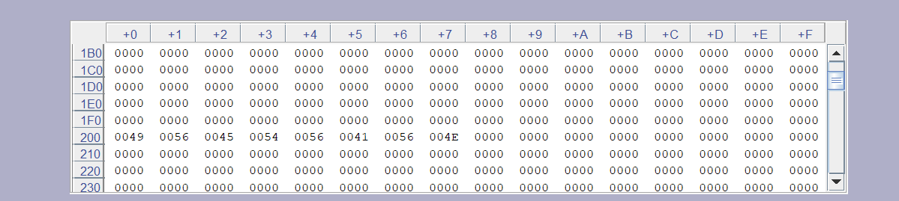

Test 2 Output Screenshot:

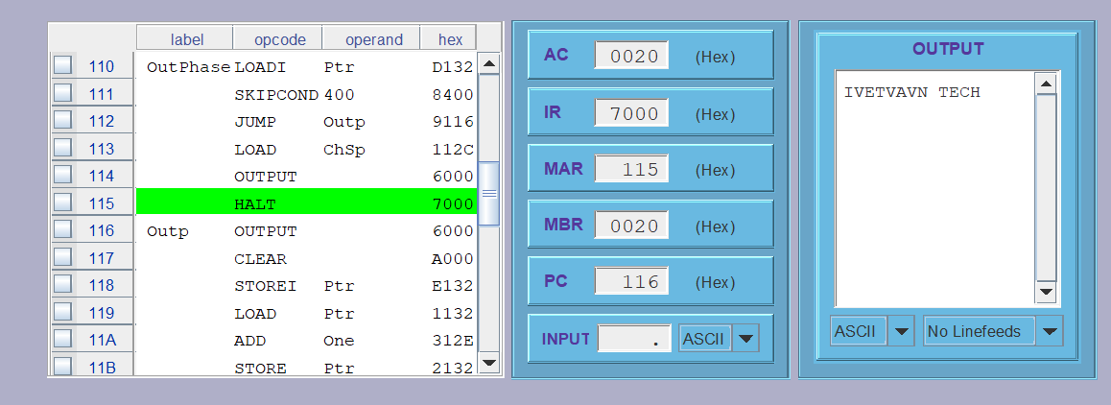

Section 4 – Conclusions:

After debugging and testing Test 1 scenario, I was able to get “IVETVAVN” as an output, then when I reran but with Test 2 scenario, I was able to get “IVETVAVNTECH” as the final output. Then after adding the space after each run, the final output became “IVETVAVN TECH”. However, in the beginning of the testing, I was confused by how the output letters were displaying vertically instead of horizontally, until I read the note on Ex4_3 mentioning that I need to change the output window control setting to "no linefeeds" so the text will print in a single line, rather than in a column of single characters. Also, knowing how inputting works in MarieSim was challenging in the beginning as I was missing the “Enter” step after typing the input. Besides, using Skipcond instruction was a little tricky in the beginning until I ran some trials and errors to understand how it works. In addition, after clearing the output characters from the memory during each run to avoid printing previous run values in the new runs, I wasn’t able to confirm the correctness of the output characters’ memory locations after the program halts, so I had to comment/uncomment the 2 lines that clear the output characters to confirm that my results are correctly located in the memory.

Accordingly, I learned that it’s important to read and test the tutorial examples firstly to get more familiar with the MarieSim environment which reduces the time spent on the project. I also learned how to divide the project into small pieces and then combine those little pieces together to be more efficient with my coding time.

Lastly, the approximate number of hours I devoted to the project was about 12-14 hours. In general, the project was very helpful in understanding assembly language for the Marie processor and it was very enjoyable to see the output of the ROT13 transform.